**Course Code:** MGNM578 **Course Instructor:** MANMEET KAUR KUKREEJA

**Acadamic Task Title:** XIAOMI: ENTERING INTERNATIONAL MARKETS

**Student Name:** Nowneesh T

**Student Roll No:** A14 **Course Title:** International Business Environment

**Course:** MBA **Module:** 1

**Academic Task No:** 1 **Date of Submission :**06-09-2022

**Section:** Q2240A **Registration NO:** 12202342

**Learning Outcomes**

I would like to express my special thanks of gratitude to my teacher **MANMEET KAUR KUKREJA** who gave me this golden opportunity to do this wonderful Assignment on **“XIAOMI: ENTERING INTERNATIONAL MARKETS”**. I came to know about so many new things. I am really thankful to them with this assignment. I learnt how to analyses the case and present its solutions for any case.

# Declaration

I declare that this Assignment is my individual work. I have not copied it from any other student’s work or from any other source except where due acknowledgement is made explicitly in the text, nor has any part been written for me by any other person.

**Student’s signature:**

**Evaluator’s comments: -**

|  |  |  |
| --- | --- | --- |
| **General Observation** | **Suggestion for Improvement** | **Best part of Assignment** |
|  |  |  |

**Introduction**

Xiaomi is one of the largest smartphone sellers in the world. It was founded in 6th April 2010 because of unsatisfaction of other mobile phone companies in China by Lie Jun and 6 members. On August 2010, Xiaomi created MIUI Operating System and raised $41 million in series A round. In August 2011, they created 1st smartphone (Mi 1). The first smartphone was the combination of MIUI firmware and Android Installation and raised $90 million in series B round. On June 2012, they received the funding of $216 million in series C round with $4 billion valuation.

In 2013, they introduced Mi3 smartphone and delivered Android based 47inch TV with Sony TV. After these sales, they become fifth most used phones in China. At end of 2013, Xiaomi sold 18.7 million smartphones. In 2014, Xiaomi expanded its sales outside China and got the domain name of mi.com for $3.6 million with company domain name as Xiaomi.com. In 2015, Ratan Tata acquired a stake in Xiaomi. In June, company expanded their products in Brazil with Redmi2 and this is the first time the company assemble their product outside China. But company’s idea failed in Brazil and left in second half of 2016.

In Starting of 2016, company launched Mi5 with Qualcomm snapdragon 820.After Mi5 launches, company launched Mi Note 3 pro in India with 1st Qualcomm snapdragon 650 processor. Xiaomi got patent from Microsoft and also they made their first sales in EU partnership with ABC data.

In 2017, Company started their 2nd unit of manufacturing with Foxconn and in April, they introduced Mi6 with 835 processor. Xiaomi made Patent Licensing Agreement with Nokia. At the end of the year, they sold 9.2 million Units during Quarter, they overtook Samsung in sales of smartphone.

After entering international market, they struggled a lot with their competitors in modern world. So, this passage further discusses what cause those problems and how to solve them.

**Issues in past years**

**Shutdown of Australian Stores**

Through its website, XiaomiStore.com.au, the unrelated company Xiaomi Store Australia started selling Xiaomi mobile phones online in Australia in March 2014. However, Xiaomi quickly "asked" that the shop close by July 25, 2014. Shortly after sales were stopped on August 7, 2014, the website was shut down. An industry commentator referred to Xiaomi's action to have the Australian website shut down as unprecedented, saying, "I've never come across this [before]. It would have to be a strategic move. At the time, Yatango (formerly MobiCity), which was based in Hong Kong, was the only online retailer selling Xiaomi mobile phones into Australia. This company closed in late 2015.

**Failures in Brazil**

The company started selling Mi 2 in Brazil. But in their website there are lot of issues like BUY button didn’t work correctly and payment failed etc.., So literally Xiaomi sold only 0.3% of smartphones in Brazil and also regulatory agency didn’t allow Xiaomi to sell their accessories. Because company did got any approval for its accessories nearly six months and this is also one of the main cause of failure in Brazil. So company left brazil in 2016.

**Patent infringement**

Xiaomi goods were not allowed to be imported or sold in India as of December 9th, 2014, according to an ex parte order issued by the High Court of Delhi. In response to a complaint brought forth by Ericsson about the infringement of a patent that was licensed under fair, reasonable, and non-discriminatory terms, an injunction was granted. The injunction was in effect up until February 5, 2015, when the High Court was supposed to call both sides in for a full hearing on the matter. The High Court allowed Xiaomi permission to sell its products with Qualcomm-based processors until January 8, 2015, on December 16. Then, Xiaomi provided a number of deals on Flipkart, including one on December 30, 2014.

**Issues in Current years**

**India bans Chinese smartphones**

Several Chinese smartphone makers have been the subject of investigations by the Indian government in recent months about charges of money laundering and the transfer of revenues and funds from India to Chinese offices in an effort to avoid collecting taxes and levies. India is currently the second-largest mobile market in the world, and it will soon surpass China as the greatest market for smartphones. However, Chinese businesses rule in India's smartphone sector.

**Revenue affect jobs**

The media reported on Saturday that Chinese smartphone manufacturer Xiaomi has cut more than 900 workers as a result of the continued financial crisis and a roughly 20% decline in Q2 sales. Nearly 3% of Xiaomi's personnel was laid off, according to the South China Post.

The firm employed 32,869 full-time workers as of June 30, 2022, with 30,110 of them situated in mainland China, predominantly in Beijing, and the remaining employees primarily located in India and Indonesia.

Following the release of its quarterly earnings on Friday, Xiaomi president Wang Xiang held a conference call with investors and stated, "In this quarter, our industry encountered several hurdles, including increasing market inflation, foreign exchange fluctuations, and uncertain political climate.

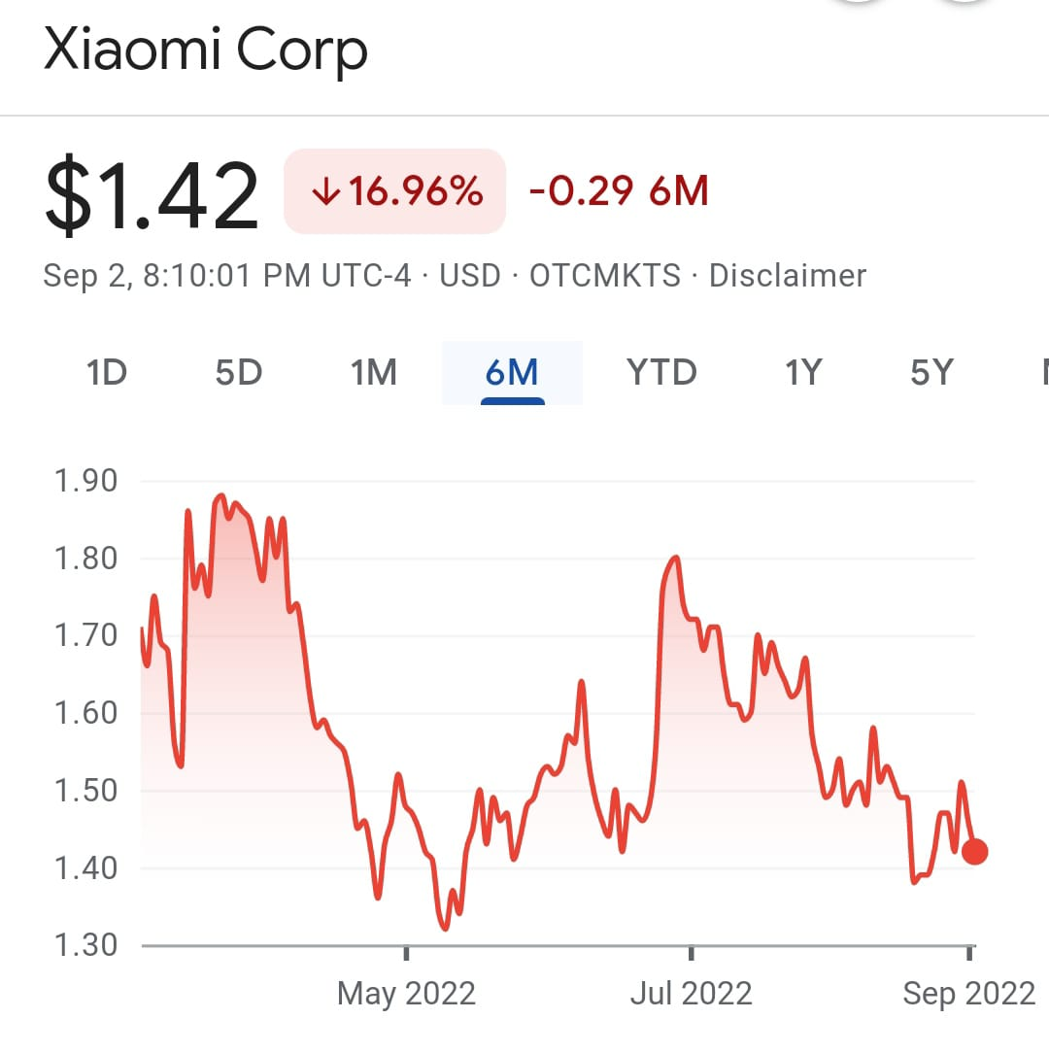

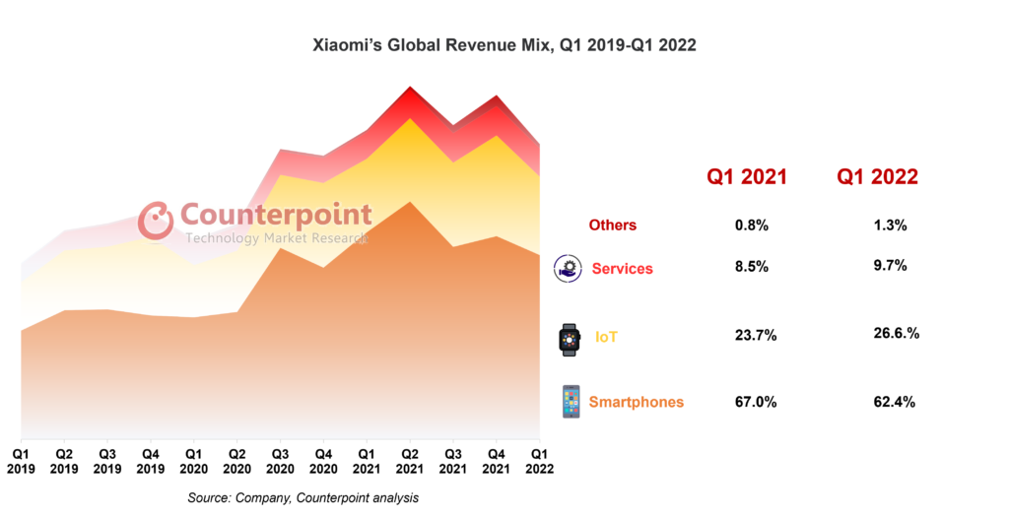

**Analysis of Problems**

**SWOT Analysis**

**Strength**

Any of the smartphones in the Phone industry is not perfect, so continuous update is needed. The company is continuously updating their software weekly to make customer friendly and introducing new smartphones on yearly basis. It made friendly tie up with more companies for the upgradation of Xiaomi products. Eg. In 2021, Mi made a collaboration with Harmon Kardon to setup dual speaker.

**Weakness**

Direct hotline and online customer support are included in Xiaomi's primary after-sales services. However, Internet users claim that MIUI community customer support and Xiaomi's hotline are ineffective in resolving user issues because they are constantly busy and engaged. Xiaomi's after-sales service is the issue that Xiaomi phone consumers are most concerned about since there aren't enough after-sales service centres and there aren't enough staff that are fluent in the local language in abroad markets.

**Opportunities**

Despite making razor-thin margins on its products, Xiaomi has a fantastic opportunity in emerging economies due to the widespread availability of smartphones. Even more significant, though, are the enormous ecosystem profits from software, application downloads, and services. Since smartphones serve as the only or primary method of Internet access in many emerging economies, it is effective to influence them online and through social media. The area in which Xiaomi excels the most is online marketing.

**Threads**

All emerged company like Apple, Samsung getting huge amount of profit in selling smartphones. Those companies will compete in both domestic and international markets. So the main thread is to sell more smartphones than those giant companies. Xiaomi had a problem with brand awareness because it is a developing company. In urban area people only knows about that brand, so they have to make awareness of their brand in worldwide.

**Solution**

Localize Xiaomi's primary area of expertise in India. First, develop an independent operating system for India only. Xiaomi uses MIUI, a Chinese-customized version of the Android operating system, as its default operating system in China. Although it is based on Android, MIUI differs greatly from Android in that it has a more attractive interface, lightning-fast performance, and a ton of added functionality. Because it is updated every Friday largely in response to requests from MiFans and feedback from the community, MIUI is entirely user driven. Enhancing user experience in accordance with consumer needs has led to customer attraction and the growth of its own fan following. In order to stand out from the competition, Xiaomi should develop an operating system specifically for the Indian market and for other countries market.

From the Mi1 in 2011 to the Mi10 in 2022, Xiaomi smartphones have consistently maintained a significant cost-effective advantage. The Qualcomm smartphone chip in the world’s largest most powerful and fastest Xiaomi flagship smartphone ensures the fluidity and high definition of the phone system. The quality of the Xiaomi phone's construction matches that of certain high-end international brands, such Motorola and Samsung.

The value of smartphones includes both hardware and software. Since Xiaomi's smartphones are assembled by other OEM manufacturers, the company is unable to control the hardware's quality. However, as assembly technology advances, hardware issues become less frequent, unless they are caused by human error. Program issues, such as system updates and software incompatibility, are another issue with quality. As more phones are sold, the issue cannot be avoided. The after-sales service industry is therefore extremely important to Xiaomi.

**Recommendation**

In the year 2022, xiaomi cuts of 900 jobs because of their revenue falls. Company is mostly spending more money in research and development. But due to the fact of Covid 19, each and everyfield is facing the issue in their income.

Alternative solutions are essential in order to raise brand recognition. Localize Xiaomi's core competency in India first. If at all possible, this entails developing an operating system that is specifically tailored for India and sells affordable goods.

First, establish a sufficient number of online groups and forums, direct phone hotlines, ensure consumer advise, and address the typical Xiaomi phone issues. To ensure the timely maintenance of a Xiaomi phone, more direct sales service locations and Xiaomi Homes should be established in large and medium-sized cities. Corporate could also partner with local retail stores in small cities to provide services to rural customers and repair phones. Service centres should compete with one another and set up a variety of key performance metrics to assure the quality of service. Xiaomi must also continue to develop employee service awareness and conduct a full spectrum of training for repair shop personnel to improve their service quality.

**Link of Resources**

1. <https://www.firstpost.com/tech/news-analysis/explained-why-india-wants-to-ban-chinese-smartphones-that-cost-less-than-rs-12000-and-what-are-its-implications-11033431.html>
2. <https://www.pcworld.idg.com.au/article/552482/exclusive_xiaomi_global_shuts_down_australian_online_stores/>
3. <https://www.91mobiles.com/xiaomi-redmi-10-2022-price-in-india#:~:text=Xiaomi%20Redmi%2010%202022%20price%20in%20India%20was%20expected%20to,Carbon%20Gray%2C%20Sea%20Blue%20colour.&text=Redmi%2010%202022%20price%20in%20India%20starts%20from%20Rs%2010%2C999>.
4. <https://timesofindia.indiatimes.com/tech-news/xiaomi-india-ban-partially-lifted-by-delhi-hc/articleshow/45532631.cms>
5. <https://www.business-standard.com/article/international/xiaomi-cuts-over-900-jobs-amid-global-as-q2-revenue-dips-20-report-122082000598_1.html>
6. I got some key points, instructions from faculties are Manmeet Kaur Kukreja & Dr. Suresh Kumar
7. <https://en.wikipedia.org/wiki/Xiaomi>